Project Name
Project Initiation Document (PID)
Date

Document Control

- Document Identification

Portfolio
Programme
Project
Author(s)
Version | 0.1
Status | Draft
Last updated
Approved by
Distribution
Related Documents | For instance; business case; requirements documentation; detailed plans

- Document History

Version | Date | Status | Author | Comment / Changes from Prior Version
0.1

- Document Reviewers/Approvers

Name | Position / Department | Reviewer | Approver
 |  | X
 |  |  | X

Document Purpose and Scope
The purpose of this document is to define the direction and scope of the [project name] project and to act as the base document for its management and the assessment of its overall success. It will outline the objectives, benefits, scope, delivery method, structure and governance in order to deliver the required changes.

Contents

1 Executive Summary 4
1.1 Roadmap 4
1.2 Costs 4
1.3 Major Risks and Issues 4
2 Project definition 5
2.1 Background 5
2.2 Vision 5
2.3 Project Objectives 5
2.4 Scope 5
2.5 Assumptions 5
2.6 Dependencies and Constraints 5
2.7 Project Approach 6
2.8 Project Impact Assessment 6
3 Business Case 6
3.1 Expected Benefits 6
3.2 Costs 6
3.3 Investment Appraisal 6
4 Project planning 7
4.1 Project Plan 7
4.2 Resource Requirements (resource plan) 7
5 Risks and Issues 7
5.1 Strategy 7
5.2 Project Risk Assessment 7
5.3 Major Issues 7
5.4 Major Risks 7
6 Project Organisation and communication 8
6.1 Project Organisational Chart 8
6.2 Role Descriptions 8
6.3 Governance Meetings 8
6.4 Key Stakeholders 8
6.5 Regular Meetings 9
6.6 Communication Tools 9
7 Project Controls 9
8 Additional Plans 10
8.1 Configuration Management Plan 10
8.2 Quality Management Plan 10
Project Acceptance Sign-off 11

Executive Summary

[Summarize the project and its objectives. Describe it so that people not familiar with the project will easily be able to understand what it is all about.
The executive summary should be a two minute read for people who want to quickly understand what the project is setting out to achieve, how it will be achieved, in which timeframes and for how much.
First write the main document; then subsequently write the executive summary]

Roadmap

The project is expected to have the following high level milestones:

# | Milestone or Phase | Date
1
2
3
4
5
6

[Insert a pictorial form of the roadmap or high level plan if available].

Costs

[Provide a brief overview of the project’s costs. Remember to also include maintenance costs after the project has been delivered.]

Major Risks and Issues

[Provide a brief overview of the project’s main risks and issues. List a maximum of 10 entries. Make it clear how this risk or issue is affecting the project and what is being done to address it.]
The main risks and issues for this project are as following;
- Issue 1. Detail of risk and mitigating action and ownership.
- Issue 2. Detail of risk and mitigating action and ownership.
- Risk 1. Detail of risk and mitigating action and ownership.
- Risk 2. Detail of risk and mitigating action and ownership.

Project definition

Background

[Provide a couple of paragraphs about the project’s background. What has it been initiated and what is it’s purpose]

Vision

[Provide a couple of paragraphs about the project’s vision. What does the customer ultimately want to achieve with the project? What is the end goal from the customer’s point of view? Insert any pictures or illustrations that are relevant]

Project Objectives

The objectives of the project are to:
- Objective one
- Objective two
- Etc.

[Remember to make the objectives as specific and measurable as possible]

Scope

[Describe the scope of the project in as much detail as you can. Include functional scope as well as non functional scope and refer to any relevant requirements documentation. Also include product breakdown structures or other relevant illustrations. This section should include scope of the product or service which you are delivering as well as the scope of the project itself. For instance; if your project is about a new IT system, describe the scope of your new system as well as scope of how it will be rolled out, who will be using it, which geographical regions etc.]

Product Scope
[List the scope of the product here]

Project Scope
[List the scope of the project here – i.e. the application of the product]

Out of scope
[List anything that is out of scope. The more granular the better]

Assumptions

[List any assumptions]

Dependencies and Constraints

[List any dependencies or constraints for the project – internal as well as external]

Project Approach

[Provide an overview of how this project will be delivered – i.e. will it be in-house developed, outsourced, done from scratch, or by reusing existing products etc.]

Project Impact Assessment

[Provide an overview of everything this project has an impact on, for instance; infrastructure, user groups, systems, working practices etc. Include impacts internal as well as external to the organisation]

Business Case

Expected Benefits

List of all expected benefits from this project - that is the ultimate objectives of the project. Make the benefits as measurable as possible. Also refer to the stand-alone business case if such a document exists]

Benefit | Description (impact and measurability) | Beneficiary
Name of benefit | In which ways is this a benefit; how will it be realized and how will it be measured? | Who will it benefit

Costs

[List all expected costs for the project in table format. Include fixed costs and variable costs for the duration of the project as well as costs involved in the handover and maintenance of the product or service after project closure.]

Investment Appraisal

[The company you work for will normally guide you regarding which model to use for the investment appraisal. Possible models include; Cost benefit analysis, Present value; Net present value, Internal rate of return, Payback period.]

Project planning

Project Plan

[Describe how the project will be delivered, in as much detail as you can. Which phases will it consists of, which technologies will be used, what will be produced, by when, by whom and how. Insert graphical plans and illustrations to support your text]

Resource Requirements (resource plan)

[Provide an overview of the resources that will be required to achieve the project’s outcome]

Risks and Issues

Strategy

[Describe the project’s risk management strategy. How will risks be identified and managed on the project]

Project Risk Assessment

[Assess the project’s overall risk level. Is this a high, medium or low level risk project based on complexity, size, scale etc? Explain your reasoning]

Major Issues

[Provide a list of the projects most serious issues at the point of initiation. Describe the nature of the issue, its impact, what is being done to address it and who owns it]

Major Risks

[Provide a list of the projects most serious risks at the point of initiation. Describe the nature of the risk, its impact, what is being done to mitigate it and who owns it]

Project Organisation and communication

Project Organisational Chart

[Provide a pictorial organisational chart of the projects steering committee and project management team. Also provide an organisational chart for the team managers reporting into the project manager]

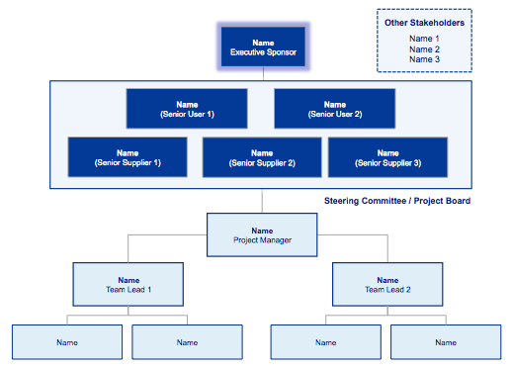 | 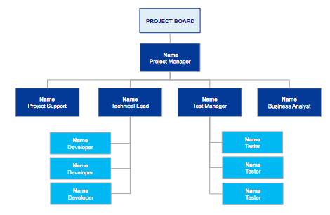

Role Descriptions

[Describe all major roles on the project; including executive sponsor, senior user, supplier, project manager, team managers, PMO etc.]

Governance Meetings

[Describe what is to be discussed at the governance or steering committee meetings and how often it will take place]

Key Stakeholders

Stakeholder Name | Area / Department | Communication Needs | Forums / Meetings
John Smith | Accounts | Weekly reports detailing expenditure | Member of working group meetings

Regular Meetings

Meeting | Frequency | Responsible / Chair | Attendees
Steering Committee meeting | Every month | Project manager | Executive Sponsor  Senior User  Senior Supplier
Working group meeting | Every week | Project manager | Project manager  Team leads  Business analyst  User groups

Communication Tools

Tool | Frequency | Responsible | Audience
Meeting minutes | Every decision making meeting | Project manager | Working group members
Newsletters | Monthly | Project manager | All stakeholders
Steering Committee Pack | Monthly | Project manager | Steering Committee members

Project Controls

Control | Description of control | Who exercises control | When / Frequency
Timesheet Approvals
Supplier contracts
Cost forecasting
Change Control
Risks & Issues
Progress Reporting
End Stage Assessments
Project Closure

Additional Plans

Configuration Management Plan

[Give a short summary of the configuration management plan and provide a link to it]

Quality Management Plan

[Give a short summary of the quality management plan and provide a link to it]

Project Acceptance Sign-off
The contents of this document are accepted and approval to proceed with Project Stage 2 is hereby granted.

Executive Sponsor Acceptance:
Name: |  | Date:
Signature: |  | Electronic Sign-off
Senior User Acceptance:
Name: |  | Date:
Signature: |  | Electronic Sign-off
Senior Supplier Acceptance:
Name: |  | Date:
Signature: |  | Electronic Sign-off

 | Susanne Madsen is an internationally recognized project leadership coach, trainer and consultant. She is the author of The Project Management Coaching Workbook (2012) and The Power of Project Leadership (2015, 2019).  Prior to setting up her own business, she worked for 17 years in the corporate sector leading large change programmes of up to $30 million for organisations such as Standard Bank, Citigroup and JPMorgan Chase. She is a fully qualified Corporate and Executive coach, an NLP Practitioner, DISC accredited and a regular contributor to the Association for Project Management (APM).  Susanne specialises in helping managers improve their leadership skills so that they can gain control of their projects and fast-track their career. She does this through a combination of training, coaching, mentoring and consulting.

"I loved this book the first time, and the revised edition is even better. Fully updated, this edition goes deep into strategies to help you lead yourself and your team more effectively. The book goes beyond theory - although you can tell the text is well-grounded in research - to give you practical tactics that you can use daily at work. When you combine powerful techniques and a willingness to do the work, you have a blend that will help you excel at delivering organisational strategy through projects. Susanne makes it easy by stepping you through the 'keys' to leadership, and you can pick and choose the approaches you think will make the most difference with your team.“ Elizabeth Harrin, The award-winning blogger behind GirlsGuideToPM.com | 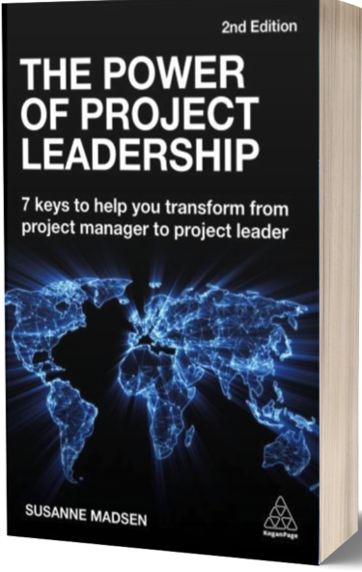


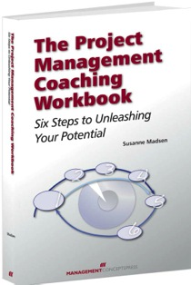 | The project Management Coaching Workbook – Six Steps to Unleashing Your Potential.  "If I were to choose ONLY two books to get my job done or do a better job as a PM then the two books I'd hold onto would be the PMBOK and Susanne's Project Management Coaching Workbook. If PMBOK is the theoretical framework, then Susanne's book is the Real World Application.. this is where the rubber hits the road. This is by far the most well written book I have read not only on the subject of Project Management but also from a Get Things Done perspective. The way she explains and assists with the GTD approach is incredible."  —Atif Hassan, Toronto, Canada

